Jeziel E. Torres Vázquez

INEL 4998 (Research)

Prof. Eduardo Ortiz

Week: March 1-5

This week's task was not about the OpenDss team. I volunteer to work with Angel Figueroa on the mounting system that the PV systems will use. For this we planned a meeting to search and investigate the types of mount, material, data sheets and more. The mount system for a PV array is important. This defined the sturdiness of the PV and resistance it has against nature. These values and parameters can be found in the data sheet the vendors provide. With this data we can see if the PV mount is the correct for our systems.

First, we search about types of mount that exist. There are two major types of mounts, the fixed and ballast. The fixed is the one that is the one that is anchored to the ceiling. This gives more sturdiness and resistance to wind and snow. Also, it gives better angles because it is stronger due to its mechanics. This type of mount gives more space to maintain the solar panels and make more installation around the PV arrays. But everything is not perfect, it also has it downsized. Because it is fixed in the ceiling, holes must be made, and this could be a potential to leak in the future.

Also, because there need to be holes made, the installation process is going to be longer because an expert needs to make the marks where the holes are going to be. The ceiling must be checked by an expert to see if the ceiling can be penetrated. Another thing that can be problematic is that an expert must seal the hole so there are no potential leaks in the building. Here is an example of a fixed PV mount to a ceiling.

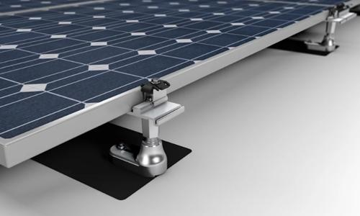

The other type of mount is the ballast system. This uses weight to maintain the system sturdy and strong. This system typically uses concrete blocks on plastic shells to get the weight where it is supposed to. This type of mount is good if someone does not want to make holes on a ceiling. Ballast system is beneficial in making the leaking problem gone forever, because the ceiling does not have to be penetrated. But because of the concrete blocks, the roof now must support more weight. This is a debility for this mount because not all roofs all build the same and there are ones that cannot resist the weight. Another bad thing about ballast is the concrete block themselves. This block must sustain all the natural weather and changes in temperature depending on your location. Because of this these blocks need to have a special treatment to make them last longer and resist more. Here is an example of a ballast mount on a roof.

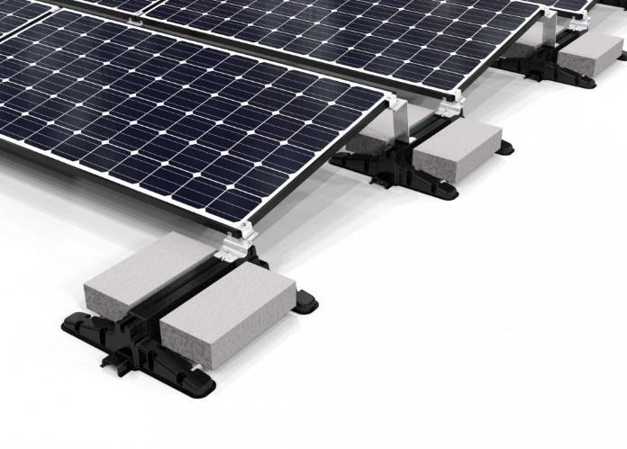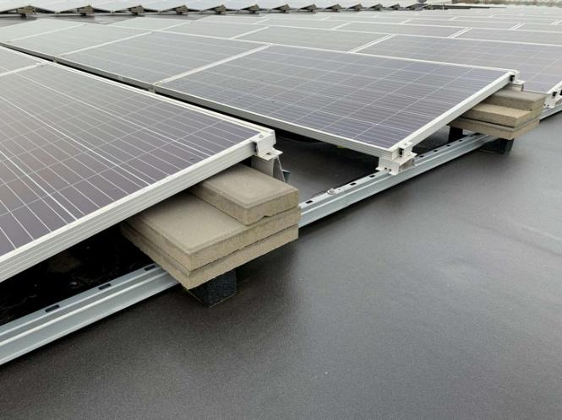

Both of the mounts have their pros and cons. Because of this Angel and I made two tables putting all this information to see which is better. In the next meeting for the Solar District Cup Team we are going to present all this information and see which the team thinks is better for our research. Here are the two tabel we use to illustrate the pros and cons.

